Welcome!!

I am very excited that I am going to be your teacher this year. We are going to learn a lot together! Along with learning comes responsibility. In this letter, I am going to tell you about some of the responsibilities you will have in our classroom. If we all work together, we can make the most of this school year.

First of all, we will be using a Check Book system in the classroom. You will get money amounts for being responsible (doing homework, participating during class, etc.). You will also earn money amounts for things like working extra hard or helping a friend. Weekly allowances can be decreased for not being prepared for class, not having your homework, or not listening to directions. The rewards include iPad time, positive notes home, special chairs to sit in, prize box, and many more.

Another thing that involves responsibility is your homework. Sometimes you will have Reading, Spelling, or Math homework. If your homework is not complete, you will have it for homework the next night, plus the homework for that night. If your homework is still not done, you will complete it at recess.

We will also be keeping a very organized assignment sheet in our class. You will earn a star or stamp every day that your assignments are complete and your parents have signed your assignment sheet. If you have 4 stickers in a week, (that means that your homework is done every night) you will receive bonus allowances!!

We are going to have a great year. I am looking forward to taking this journey with you!

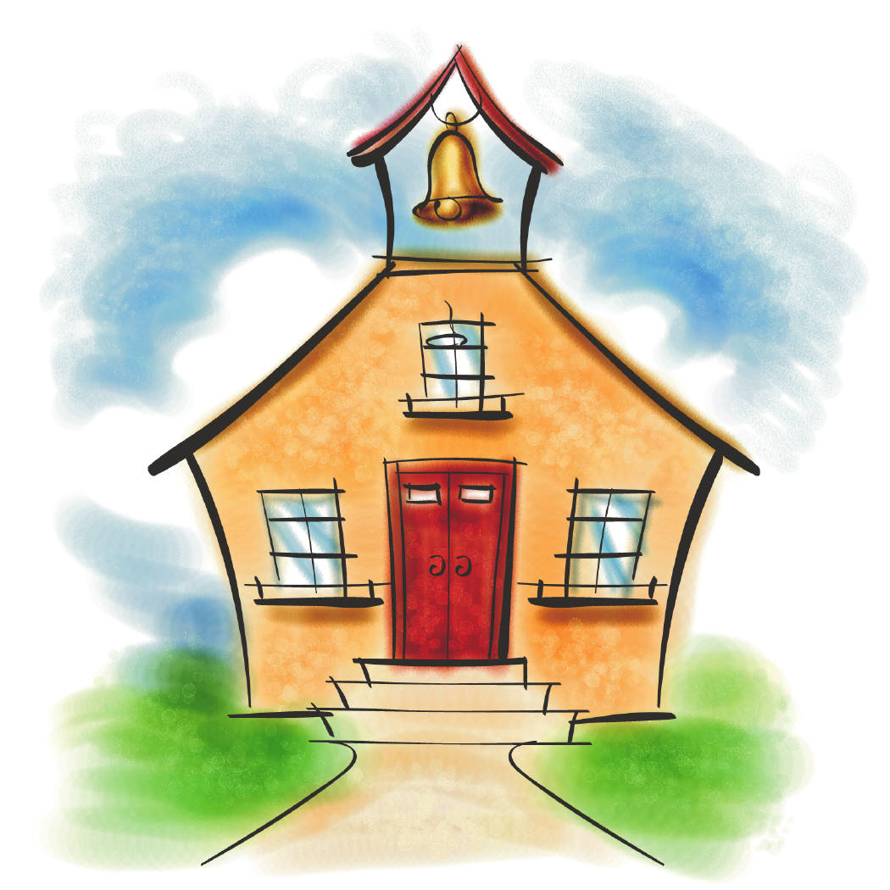Sincerely,

Miss Johns